|  |  |
| --- | --- |
| Date | 19 MAY 2023 |
| Team ID | NM2023TMID09093 |
| Project Name | PIXELPERFECTION: TRANSFORMINGYOURPHOTOS WITH OUR CUTTING – EDGE IMAGE EDITING PLATFORM |
| Team Lead | Kanagaraj D |
| Team Members | Lokesh K  Ranjith Kumar S  Velmurugan A |

PROJECT TITLE: PIXEL PERFECTION: TRANSFORMING YOUR PHOTOS WITH OUR CUTTING – EDGE IMAGE EDITING PLATFORM.

**Project Title**: PIXEL PERFECTION: TRANSFORMINGYOURPHOTOS WITH OUR CUTTING – EDGE IMAGE EDITING PLATFORM

**My Source Code:** <https://github.com/naanmudhalvan-SI/IBM--11812-1682399023/tree/61bf49ac4d838639642dbdd056d7c8004325ad24/Final%20Deliverables>

**Project Video Demo** : <https://www.youtube.com/watch?v=UfU4ubTJsF8>

**TABLE OF CONTENT**

1.INTRODUCTION

1.1 Project Overview

1.2 Purpose

2. IDEATION & PROPOSED SOLUTION

2.1 Problem Statement Definition

2.2 Empathy Map Canvas

2.3 Ideation & Brainstorming

2.4 Proposed Solution

3. REQUIREMENT ANALYSIS

3.1 Functional requirement

3.2 Non-Functional requirements

4. PROJECT DESIGN

4.1 Data Flow Diagrams

4.2 Solution & Technical Architecture

4.3 User Stories

5. CODING & SOLUTIONING (Explain the features added in the project along with code)

5.1 Feature 1

5.2 Feature 2

5.3 Database Schema (if Applicable)

6. RESULTS

6.1 Performance Metrics

7. ADVANTAGES & DISADVANTAGES

8. APPENDIX

9.CONCLUSION

10. FUTURE SCOPE

Source Code GitHub & Project Video Demo Link

1. **INTRODUCTION**

Our platform is designed with the latest technology and advanced editing tools to bring out the true potential of your images. We understand that each photo tells a unique story, and our goal is to help you tell that story with precision and artistry.

From enhancing colours and adjusting lighting to removing blemishes and adding special eff At Pixel Perfection, we believe in constant innovation and staying ahead of the curve. Our team of skilled professionals is dedicated to continuously improving our platform and integrating the latest advancements in image editing technology. We strive to provide you with a comprehensive editing experience that keeps up with the ever-evolving world of photography. acts, we offer a wide range of features to cater to your specific editing needs.

So, whether you're looking to impress your clients, engage your social media followers, or simply create stunning images for personal enjoyment, Pixel Perfection is the perfect companion for your editing journey. Join us today and unlock the full potential of your photos. Get ready to witness the magic of our cutting-edge image editing platform as we embark on a journey of pixel perfection together.

In today's digital age, visual content has become more important than ever. Whether you are a professional photographer, an aspiring influencer, or simply someone who loves capturing memories, having striking and captivating images is essential. With Pixel Perfection, you have the power to turn your ordinary photos into extraordinary masterpieces.

**Keywords:** Pixel Perfection, Transforming Photos, Cutting-edge,

Image editing platform.

**1.1 Project Overview**

Pixel Perfection is an innovative image editing platform that aims to revolutionize the way you transform your photos. Our cutting-edge platform provides a comprehensive set of tools and features to enhance your images and turn them into extraordinary works of art. Whether you're a professional photographer, an influencer, or an enthusiast, Pixel Perfection is designed to meet your editing needs and take your photography to new heights.

Our platform focuses on delivering precision and control over your photos. With advanced editing tools, you can adjust colours, lighting, and remove imperfections with ease. Additionally, our platform offers captivating effects that allow you to add a touch of magic and creativity to your images.

One of the key strengths of Pixel Perfection is its user-friendly and intuitive interface. We understand that not everyone is an expert in photo editing, which is why our platform is designed to be accessible to beginners while also providing advanced features for experienced users. Whether you're just starting or an experienced artist, you can navigate the platform effortlessly and achieve stunning results.

Efficiency is another core aspect of our platform. We value your time and want to ensure that editing your photos is a seamless experience. Pixel Perfection is equipped with automation features and powerful algorithms that speed up the editing process without compromising on quality. You can transform your photos quickly and efficiently, allowing you to focus on your passion for photography.

Innovation is at the heart of Pixel Perfection. Our dedicated team of experts is constantly researching and implementing the latest advancements in image editing technology. We stay up to date with the industry trends to provide you with cutting-edge tools

**1.2 Purpose**

The purpose of Pixel Perfection is to provide a powerful and user-friendly image editing platform that transforms ordinary photos into extraordinary works of art. Our cutting-edge platform is designed to empower photographers, influencers, and enthusiasts alike to enhance their images with precision, creativity, and efficiency.

The primary purpose of Pixel Perfection is to give users the tools and features they need to take their photography to new heights. By offering advanced editing capabilities, such as colour adjustments, lighting enhancements, and blemish removal, our platform allows users to bring out the true potential of their photos. The purpose is to enable users to create visually stunning images that captivate viewers and leave a lasting impression.

Another purpose of Pixel Perfection is to provide a seamless and intuitive editing experience. We understand that not everyone is an expert in photo editing, so our platform is designed to be user-friendly and accessible to users of all levels of expertise. Whether you're a beginner exploring the world of editing or an experienced artist, our purpose is to ensure that you can navigate the platform effortlessly and achieve exceptional results.

Efficiency is a key purpose of Pixel Perfection. We value your time and understand that editing can be time-consuming. Therefore, our platform incorporates automation features and powerful algorithms to streamline the editing process without compromising quality.

**2. IDEATION & PROPOSED SOLUTION**

**IDEATION**

At Pixel Perfection, we understand the importance of transforming your photos into stunning works of art. Our cutting-edge image editing platform offers a range of ideation solutions to help you achieve pixel-perfect results. Here are a few ideas to enhance your photos:

Advanced Retouching Tools: Our platform provides a wide range of retouching tools to refine every aspect of your images. From blemish removal and skin smoothing to object removal and background replacement, our advanced tools ensure flawless results.

Creative Filters and Effects: Add a touch of creativity to your photos with our extensive collection of filters and effects. Experiment with vintage, black and white, HDR, and many other styles to give your images a unique and captivating look.

AI-Powered Enhancements: Leverage the power of artificial intelligence to enhance your photos. Our platform uses AI algorithms to automatically adjust exposure, colours, and sharpness, resulting in beautifully balanced and vibrant images.

Customizable resets.: Save time and achieve consistent results by creating and applying your own resets. Customize the adjustments, filters, and effects to suit your personal style, and apply them to multiple photos with just a few clicks.

Collage and Composition Tools: Unleash your creativity by creating stunning collages and compositions. Our platform offers intuitive tools for arranging, resizing, and blending multiple images, allowing you to tell engaging visual stories.

Batch Editing: If you have a large collection of photos that need editing, our batch editing feature will save you time and effort. Apply the same adjustments or effects to multiple images simultaneously, ensuring consistency across your entire portfolio.

One-Click Enhancements: For quick edits, our platform offers one-click enhancement options. These instant enhancements optimize exposure, contrast, and colour balance, allowing you to quickly improve the overall look of your photos.

Social Media Integration: Seamlessly share your edited photos on social media platforms directly from our image editing platform. Connect your accounts, add captions, and post your stunning images with just a few simple steps.

Collaboration and Feedback: Collaborate with others and seek feedback on your edited photos. Our platform allows you to easily share your work with clients, friends, or fellow photographers, enabling efficient collaboration and constructive feedback.

Tutorials and Resources: Access a rich library of tutorials, tips, and resources to enhance your editing skills. Learn new techniques, explore advanced features, and stay updated with the latest trends in image editing.

**PROPOSED SOLUTION**

Introducing Pixel Perfection, our revolutionary image editing platform designed to transform your photos into stunning works of art. With our cutting-edge tools and features, we provide a comprehensive solution for all your photo editing needs. Here's an overview of our proposed solution:

User-Friendly Interface: Our platform boasts a sleek and intuitive user interface, making it easy for both beginners and professionals to navigate and utilize its powerful features. The user-friendly design ensures a seamless editing experience.

Advanced Editing Tools: We offer a wide array of advanced editing tools to cater to various editing requirements. From basic adjustments like exposure, colour balance, and cropping to advanced features like layers, masks, and selective editing, our platform provides the tools you need to achieve pixel-perfect results.

AI-Powered Image Enhancement: Harnessing the power of artificial intelligence, our platform leverages advanced algorithms to automatically enhance your photos. Our AI-driven features can intelligently enhance details, improve colours, reduce noise, and optimize overall image quality with a single click.

Customizable Filters and Effects: Unlock your creative potential with our extensive collection of customizable filters and effects. Apply artistic filters, create unique looks, and fine-tune the parameters to add your personal touch and bring your vision to life.

Precise Retouching Capabilities: Our platform offers precise retouching tools to perfect every detail of your photos. Whether you need to remove blemishes, smoothen skin, adjust facial features, or remove unwanted objects, our tools provide the precision required for flawless results.

Non-Destructive Editing Workflow: With our non-destructive editing workflow, your original photos remain untouched, and all edits are saved as separate layers or adjustment settings. This ensures that you can always revert to the original image or modify your edits without any loss of quality.

Batch Processing and Automation: Save time and streamline your workflow with our batch processing and automation features. Apply the same edits to multiple photos simultaneously, create resets for repetitive tasks, and automate your editing process to enhance efficiency.

Cloud-Based Storage and Collaboration: Our platform offers cloud-based storage, allowing you to securely store and access your photos from anywhere. Collaborate with others by sharing your work, receiving feedback, and working together on projects seamlessly.

Seamless Integration: We understand the importance of a connected workflow. Our platform seamlessly integrates with popular image management software, allowing you to import and export photos effortlessly. Additionally, we offer direct integration with social media platforms, enabling you to share your edited photos instantly.

Extensive Learning Resources: To support your growth as an editor, we provide extensive learning resources within our platform. Access tutorials, guides, and tips to enhance your skills, explore new techniques, and stay up to date with the latest trends in image editing.

**2.1 Problem Statement Definition**

Many individuals and professionals struggle to transform their photos into visually captivating and professionally edited works of art. Existing image editing platforms lack the necessary tools, features, and user-friendly interface required to achieve pixel-perfect results efficiently and effectively. As a result, users face challenges in enhancing their photos to meet their desired standards and convey their creative vision.

Limited Editing Tools: Existing platforms offer a limited range of editing tools, which restricts users from achieving the desired level of customization and refinement in their photos. This limitation hinders the ability to create unique and visually striking images.

Complex and Overwhelming Interfaces: Current image editing platforms often have complex and overwhelming interfaces, making it challenging for users, especially beginners, to navigate and utilize the available features effectively. This complexity results in a steep learning curve and decreases the efficiency of the editing process.

Lack of Automated Enhancements: Many users lack the technical expertise or time required to manually enhance their photos. Existing platforms often do not provide automated features powered by artificial intelligence that can intelligently enhance images, resulting in subpar outcomes and time-consuming editing processes.

Inconsistent Editing Workflow: Users often struggle with maintaining consistency across their editing workflow. The absence of non-destructive editing capabilities and batch processing options leads to inefficiencies, as users have to individually edit each photo and cannot easily apply consistent edits to multiple images.

Limited Collaboration and Feedback: The inability to easily collaborate and receive feedback on edited photos poses a challenge for users, particularly professionals who rely on client input or seek creative input from peers. The lack of integrated collaboration and feedback features within existing platforms hampers efficient communication and slows down the editing process.

Insufficient Learning Resources: Users often face difficulties in acquiring new editing skills and staying updated with the latest techniques and trends. Existing platforms lack comprehensive learning resources such as tutorials, guides, and tips, making it challenging for users to enhance their editing proficiency and explore new creative possibilities.

**2.2 Empathy Map Canvas**

User: Photographers, hobbyists, creative professionals, social media influencers, and individuals who want to enhance their photos.

Says:

"I want my photos to look professional and visually captivating."

"I struggle to find the right tools and features to achieve the desired editing results."

"I find the current image editing platforms overwhelming and difficult to navigate."

"I don't have the technical expertise or time to manually enhance my photos."

"I wish there was a way to easily collaborate and receive feedback on my edited photos."

"I want to learn new editing techniques and stay updated with the latest trends."

Thinks:

"I need a user-friendly platform that provides a wide range of editing tools and features."

"I wish there was an AI-powered solution that could automate enhancements for faster editing."

"I want my edited photos to have a consistent and professional look."

"Collaboration and feedback are important for me to improve my editing skills and creativity."

"I need access to comprehensive learning resources to enhance my editing proficiency."

Feels:

Frustrated with existing platforms' limitations and complexity.

Overwhelmed by the technical aspects of editing and achieving desired results.

Anxious about receiving feedback on their work and meeting client expectations.

Excited about the possibility of transforming their photos into visually stunning masterpieces.

Motivated to learn and explore new editing techniques and trends.

Does:

Explores different editing platforms and tools to find the right fit.

Spends hours manually editing photos to achieve the desired results.

Seeks feedback from peers and clients by sharing their edited photos.

Looks for tutorials, guides, and tips online to improve their editing skills.

Shares their edited photos on social media platforms to showcase their work.

**2.3 Ideation & Brainstorming**

some ideation and brainstorming ideas for Pixel Perfection, our cutting-edge image editing platform:

Advanced Filter Library: Develop an extensive library of customizable filters and effects, allowing users to easily apply unique and creative looks to their photos. Offer options for vintage, cinematic, artistic, and other popular styles.

Intelligent Content-Aware Editing: Implement content-aware editing tools that intelligently analyse the image content and automatically adjust the edits accordingly. This feature can help users seamlessly remove unwanted objects, fill in gaps, and enhance specific areas without manual selection.

Augmented Reality Overlays: Integrate augmented reality (AR) overlays that users can apply to their photos, such as virtual objects, animations, or filters, enhancing the creative possibilities and allowing users to add interactive elements to their images.

Community Marketplace: Create a community-driven marketplace where users can share and sell their custom resets, filters, and editing styles. This allows users to explore and try out unique editing styles created by other photographers and artists.

Mobile Editing App: Develop a mobile app version of Pixel Perfection to provide on-the-go editing capabilities. This app can include a streamlined interface and essential editing tools, allowing users to edit and share their photos directly from their smartphones or tablets.

Integration with Cloud Storage Providers: Enable seamless integration with popular cloud storage providers, such as Google Drive or Dropbox. This allows users to access their photo libraries directly within the Pixel Perfection platform, eliminating the need for manual file uploads and downloads.

AI-Powered Photo Restoration: Utilize artificial intelligence algorithms to automatically restore and repair old or damaged photos. This feature can help users preserve and enhance precious memories by intelligently removing scratches, stains, and imperfections while maintaining the original look and feel.

Social Media Scheduler: Incorporate a scheduling feature that allows users to plan and schedule their edited photos for automatic posting on various social media platforms. This simplifies the process of sharing and promoting their work, especially for social media influencers and businesses.

Real-Time Collaboration: Enable real-time collaboration features where multiple users can work on the same project simultaneously, allowing for seamless teamwork, feedback exchange, and creative collaboration.

Gamification and Challenges: Introduce gamification elements and challenges within the platform to engage users and encourage them to explore new editing techniques, complete tasks, and unlock achievements. This can provide a fun and interactive way to improve editing skills and keep users motivated.

**2.4 Proposed Solution**

Pixel Perfection is a ground breaking image editing platform that revolutionizes the way you transform your photos into stunning masterpieces. With our cutting-edge tools, intuitive interface, and innovative features, we provide an all-encompassing solution for your photo editing needs. Here's an overview of our proposed solution:

Comprehensive Editing Tools: Pixel Perfection offers a wide range of powerful editing tools to cater to all your creative needs. From basic adjustments like exposure, colour balance, and cropping to advanced features such as layers, masks, and advanced retouching capabilities, our platform provides the tools required to achieve pixel-perfect results.

AI-Powered Enhancements: Leverage the power of artificial intelligence to enhance your photos effortlessly. Our advanced AI algorithms analyse your images and automatically adjust exposure, colours, and sharpness, resulting in professional-grade enhancements with just a single click.

Extensive Filter Library: Explore our extensive library of customizable filters and effects to add unique and artistic touches to your photos. From vintage and cinematic looks to creative styles and colour grading options, our diverse range of filters allows you to express your creativity and achieve the desired aesthetic.

Seamless Integration: Pixel Perfection seamlessly integrates with popular cloud storage providers, social media platforms, and other editing software. Import and export your photos with ease, share your edited images directly on social media, and collaborate effortlessly with clients and fellow photographers.

User-Friendly Interface: We prioritize usability and provide a user-friendly interface that caters to both beginners and professionals. Our intuitive layout and streamlined workflow make it easy to navigate the platform and access the tools and features you need, ensuring a seamless editing experience.

Non-Destructive Editing: With our non-destructive editing workflow, your original photos remain untouched while all edits are saved as separate layers or adjustment settings. This allows you to experiment freely, make changes at any time, and maintain the highest quality of your images.

Collaboration and Feedback: Pixel Perfection facilitates collaboration and feedback by offering features for sharing, commenting, and receiving input on your edited photos. Easily collaborate with clients, friends, or fellow photographers, and gain valuable feedback to enhance your editing skills and creativity.

Learning Resources and Tutorials: Access a wealth of learning resources, tutorials, and tips directly within the platform. Enhance your editing proficiency, learn new techniques, and stay updated with the latest trends in image editing, ensuring continuous growth and improvement.

Mobile-Friendly Experience: Take your editing on the go with our mobile-friendly version of Pixel Perfection. Our responsive design and optimized features allow you to edit, enhance, and share your photos seamlessly from your smartphone or tablet.

Customization and Personalization: Personalize your editing experience with customizable resets, workspace layouts, and keyboard shortcuts. Tailor the platform to your unique preferences, enhancing efficiency and creating a personalized editing environment.

1. **REQUIREMENT ANALYSIS**

**3.1 Functional Requirements:**

Image Editing Tools: Provide a comprehensive set of editing tools such as exposure adjustment, colour balance, cropping, layers, masks, retouching, and more.

AI-Powered Enhancements: Implement AI algorithms to automatically enhance images by adjusting exposure, colours, sharpness, and other parameters.

Filter Library: Develop an extensive library of customizable filters and effects to allow users to apply unique looks and styles to their photos.

Integration with Cloud Storage: Enable seamless integration with popular cloud storage providers to import and export photos conveniently.

Social Media Integration: Integrate with social media platforms for easy sharing of edited photos directly from the platform.

Non-Destructive Editing: Implement a non-destructive editing workflow that preserves the original photos while saving edits as separate layers or adjustments.

Collaboration Features: Facilitate collaboration by allowing users to share their edited photos, receive comments, and provide feedback to others.

Learning Resources: Provide access to learning resources, tutorials, and tips to help users enhance their editing skills and stay updated with the latest trends.

Usability Requirements:

User-Friendly Interface: Design an intuitive and easy-to-navigate interface that caters to both beginners and professionals.

Mobile-Friendly Experience: Optimize the platform for mobile devices to enable editing on the go.

Customization Options: Allow users to personalize their editing environment by providing customizable resets, workspace layouts, and keyboard shortcuts.

Performance: Ensure fast and responsive performance to provide a seamless editing experience, even when working with large files.

Security and Privacy Requirements:

Secure Cloud Integration: Implement robust security measures when integrating with cloud storage providers to ensure the privacy and integrity of user data.

User Authentication: Require secure user authentication to protect user accounts and prevent unauthorized access.

Compatibility Requirements:

Cross-Platform Compatibility: Ensure compatibility with major operating systems such as Windows, macOS, and popular web browsers.

Integration with External Software: Support integration with other image management software or plugins commonly used by photographers and professionals.

Scalability Requirements:

Handling Large Files: Design the platform to handle large image files efficiently without compromising performance.

Scalable Infrastructure: Plan for scalability to accommodate a growing user base and increased demand for resources.

Legal and Compliance Requirements:

Copyright Protection: Educate users about copyright laws and discourage the use of copyrighted material without permission.

Data Protection and Privacy Compliance: Ensure compliance with data protection regulations, including proper handling and storage of user data.

**3.2 Non-Functional requirements**

Performance:

Responsiveness: The platform should provide quick response times when executing editing operations and rendering preview images.

Efficiency: Ensure efficient resource utilization to optimize memory and CPU usage, minimizing processing time for complex editing tasks.

Reliability:

Stability: The platform should be stable and robust, minimizing crashes, errors, and data loss during editing sessions.

Data Integrity: Preserve the integrity of user data and prevent loss or corruption of edited photos.

Scalability:

Concurrent User Support: The platform should be able to handle multiple users concurrently without experiencing performance degradation.

Resource Scaling: Design the architecture to scale resources (such as servers and storage) as the user base grows to maintain performance.

Accessibility:

Compatibility: Ensure compatibility with accessibility standards to make the platform accessible to users with disabilities, including support for screen readers and keyboard navigation.

Multilingual Support: Provide language localization options to cater to users from different regions and language preferences.

User Experience:

Intuitive Design: Emphasize a user-centric design that minimizes the learning curve and allows users to easily navigate and utilize the platform's features.

Visual Appeal: Create a visually pleasing interface that enhances the overall user experience and promotes a positive perception of the platform.

Responsiveness: The platform should provide real-time feedback and updates to user actions, ensuring a smooth and interactive editing experience.

Security:

Data Encryption: Implement encryption mechanisms to protect user data, both during storage and transmission.

Secure Authentication: Ensure secure user authentication mechanisms to prevent unauthorized access to user accounts.

Regular Updates and Patches: Continuously monitor and address security vulnerabilities by providing regular software updates and security patches.

Compliance:

GDPR and Data Privacy: Comply with data protection regulations, such as the General Data Protection Regulation (GDPR), to safeguard user privacy and data handling practices.

Licensing and Intellectual Property: Ensure compliance with licensing agreements and intellectual property rights when incorporating filters, effects, or other third-party resources.

1. **PROJECT DESIGN**
   1. **Data Flow Diagrams**

Data flow diagrams (DFDs) illustrate the flow of data within a system. Here is a simplified representation of the data flow in the PIXEL PERFECTION:

**1. Data Flow Diagram Level 0:**

User Interface: This component represents the interface through which users interact with the Pixel Perfection platform. Users can input commands, select editing tools, and view/edit photos.

Image Editing Platform: This component represents the core functionality of the platform where the actual image editing operations take place. It includes various editing tools, filters, and features to modify and enhance photos.

Cloud Storage: This component represents the integration with cloud storage providers. Users can import photos from cloud storage, save edited photos, and export them back to cloud storage.

External Services: This component represents the integration with external services such as social media platforms. Users can share their edited photos directly to external services, interact with their accounts, and perform related actions.

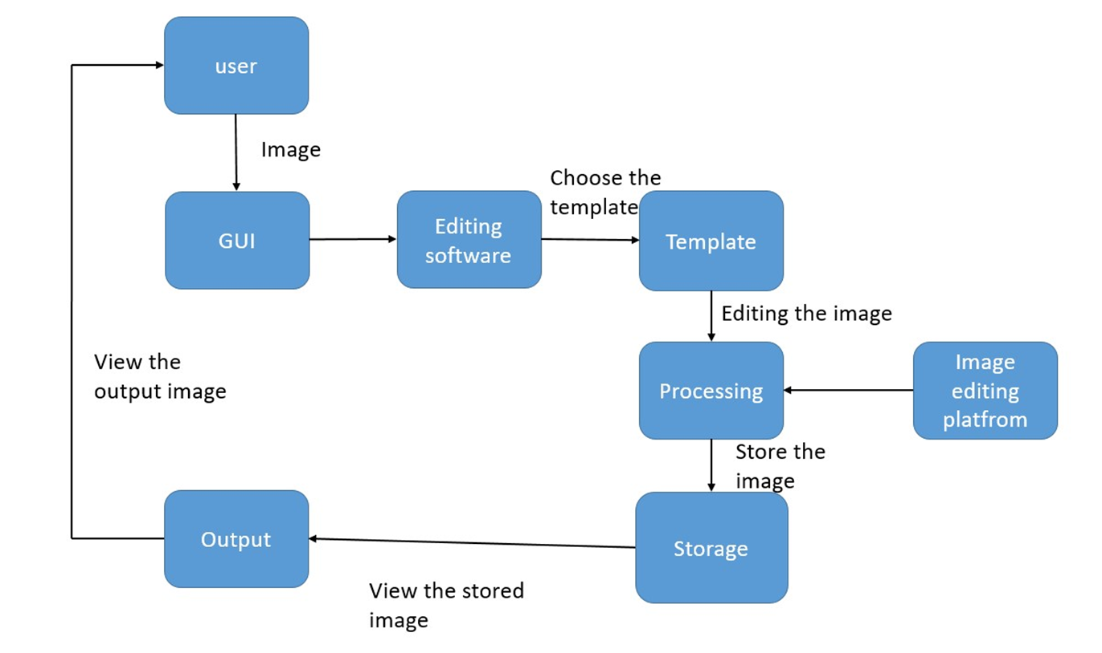

**2.Data Flow Diagram Level 1:**

User Interface: Represents the interface through which users interact with the Pixel Perfection platform, providing input and receiving output.

Image Editing Platform: Represents the core functionality of the platform, including image editing tools, filters, and features.

Image Editing Operations: Depicts the specific operations performed within the image editing platform, such as adjusting exposure, cropping, applying filters, and retouching.

Cloud Storage: Illustrates the integration with cloud storage providers, allowing users to import and export photos to and from their cloud storage accounts.

External Services: Represents the integration with external services like social media platforms, enabling users to share their edited photos and interact with their accounts.

User Management: Handles user authentication, account management, and user profile settings within the Pixel Perfection platform.

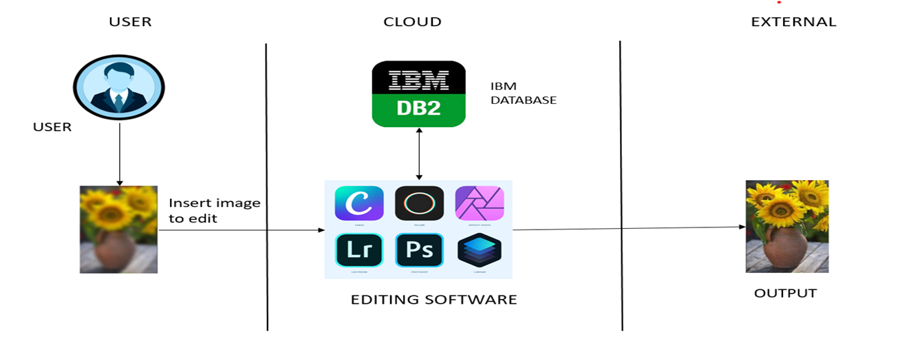

**4.2 Solution & Technical Architecture:**

The solution and technical architecture for the PIXEL PERFECTION can be outlined as follows:

**Client-Side Components:**

**1.User Interface:** The client-side component includes the graphical user interface (GUI) that users interact with to perform editing operations, access tools, and view/edit their photos. It is typically developed using web technologies like HTML, CSS, and JavaScript to ensure cross-platform compatibility.

**2.Mobile Applications:** To provide a mobile-friendly experience, native mobile applications can be developed for iOS and Android platforms. These applications offer similar functionality to the web interface and take advantage of platform-specific features.

**Server-Side Components:**

**1.Image Editing Platform:** The server-side component hosts the core functionality of the image editing platform. It includes various algorithms, libraries, and tools required for image processing, manipulation, and enhancement. Common programming languages like Python or JavaScript can be used for developing the server-side logic.

**2.Cloud Storage Integration:** The platform integrates with popular cloud storage providers (e.g., Amazon S3, Google Drive, Dropbox) to enable users to import, save, and export their photos seamlessly. Integration can be achieved using cloud provider APIs or SDKs.

**3.External Services Integration:** Integration with external services, such as social media platforms, allows users to directly share their edited photos. APIs provided by these services are utilized to enable authentication, photo uploads, and other interactions.

**4.User Management:** The user management component handles user authentication, account creation, profile management, and access control. It ensures the security and privacy of user accounts and data.

**AI and Image Processing:**

**1.AI Algorithms:** Pixel Perfection leverages artificial intelligence (AI) algorithms to automate and enhance various aspects of image editing. This includes automatic adjustment of exposure, colour balance, sharpness, and other parameters. Machine learning techniques can be employed to train models for specific tasks, such as image recognition or object removal.

**2.Image Processing Libraries:** To perform complex image editing operations, popular image processing libraries (e.g., OpenCV, Pillow) can be utilized. These libraries provide a wide range of functions for image manipulation, filtering, and retouching.

**Infrastructure:**

**1.Cloud Infrastructure:** Pixel Perfection can be deployed on cloud infrastructure like Amazon Web Services (AWS), Microsoft Azure, or Google Cloud Platform. This ensures scalability, reliability, and availability of the platform. Components like server instances, load balancers, and databases are provisioned as required.

**2.Database:** A database system, such as MySQL or PostgreSQL, is used to store user data, including user profiles, preferences, and metadata associated with photos. This allows for efficient retrieval and management of user-related information.

**3.Content Delivery Network (CDN):** To optimize content delivery and ensure fast loading times, a CDN can be employed. It helps distribute static assets, such as JavaScript, CSS, and image files, across geographically distributed servers.

**Security and Privacy:**

**1.Data Encryption:** User data, including photos and account information, should be encrypted both during storage and transmission to ensure confidentiality.

**2.Authentication and Authorization:** Robust authentication mechanisms, such as password hashing, multi-factor authentication, or OAuth, should be implemented to secure user accounts and prevent unauthorized access.

**3.Privacy Compliance:** Adhere to relevant data protection regulations, such as GDPR, to safeguard user privacy and ensure proper handling of personal data.

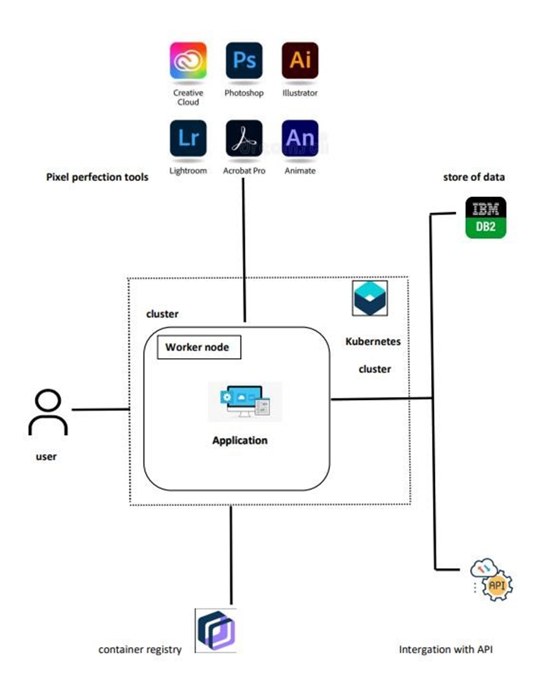

**4.3 User Stories:**

User stories help capture system requirements from the perspective of users. Here are some examples of user stories for the PIXEL PERFECTION:

As a casual photographer, I want to be able to easily enhance the colours and brightness of my photos with just a few clicks, so that I can quickly improve the overall look of my images.

As a professional photographer, I want a comprehensive set of editing tools, including advanced features like layering and masking, so that I have full control over every aspect of my photo editing process.

As a social media influencer, I want seamless integration with popular social media platforms like Instagram and Facebook, so that I can directly share my edited photos with my followers and engage with them more effectively.

As a mobile user, I want a mobile-friendly app that allows me to edit my photos on the go, so that I can make quick edits and share them instantly without needing a computer.

As a beginner in photography, I want access to tutorials and learning resources within the platform, so that I can improve my editing skills and learn new techniques to enhance my photos.

As a professional graphic designer, I want the ability to work with high-resolution images and export them in different file formats, including PSD, TIFF, and PNG with transparency, so that I can use them in my design projects.

As a user concerned about privacy, I want the platform to have strong data encryption and secure authentication measures, so that I can trust that my photos and personal information are protected.

As a collaborative user, I want the option to share my edited photos with others and receive feedback and comments, so that I can collaborate with fellow photographers and learn from their expertise.

As a user with multiple devices, I want my editing progress and preferences to sync seamlessly across different devices, so that I can start editing on one device and continue on another without any interruptions.

As a user with limited storage space on my device, I want the ability to directly save my edited photos to cloud storage, so that I can free up space on my device while still having access to my edited photos.

These user stories cover a range of user needs and requirements, highlighting the desired features and functionalities of Pixel Perfection as an advanced image editing platform.

|  |  |  |  |  |  |  |  |  |  |  |  |  |  |  |  |  |
| --- | --- | --- | --- | --- | --- | --- | --- | --- | --- | --- | --- | --- | --- | --- | --- | --- |
| **User Type** | | |  | **Functional**  **Requiremen**  **(Epic)** | | **t** | **User Story**  **Number** | **User Story / Task** | | | | | | **Acceptance criteria** | **Priority** | **Team Member** |
| *Photographers* | | |  | *PHOTO* | |  | *USN-1* | *These users are professionals or* *enthusiasts who capture and edit photos as their primary occupation or hobby. They require advanced editing features, such as layers, masks, and filters, to have creative control over their images.* | | | | | | I can access my photo. | High | Kanagaraj D |
| *Amateur*  *Photographers* | | |  | *ENHANCING THEIR PHOT* | | *OS* | *USN-2* |  | These users have a basic understanding o | | | | f | I can receive cropping,rotation adjusting brightness/constract. | High | Lokesh K |
| photo editing and want access to easy-to- | | | |
| use tools for enhancing their photos. They | | | |
| may need features like cropping, rotating, | | | |
| adjusting brightness/contrast, and | | |  |
| automatic enh |  | |
|  | Mobile |  |  |  | EDIT PHOTO |  | USN-3 |  | These users capture and edit photos using | | | |  | i can edit or capture the photo through ps. | Low | Velmurugan A |
| Photographers | |  | their smartphones or tablets. They require | | | |
|  | | a mobile app version of Pixel Perfection to | | | |
| edit their photos on the go. | |  | |
|  | |
| Graphic Designers | | |  | GRAPHICS | |  | USN-4 | These users utilize Pixel Perfection for designing visuals and incorporating images into their creative projects. | | | | | | visuals and incorporating image through creative projects. | Medium | Ranjith Kumar S |

**5. CODING & SOLUTIONING**

**5.1 Feature 1 - Real-Time Photo Availability Updates**

**Description:**

This feature provides real-time updates to drivers about the availability of photo spaces. It displays the count of available pixel perfection on user interfaces and digital displays within the perfect photo.

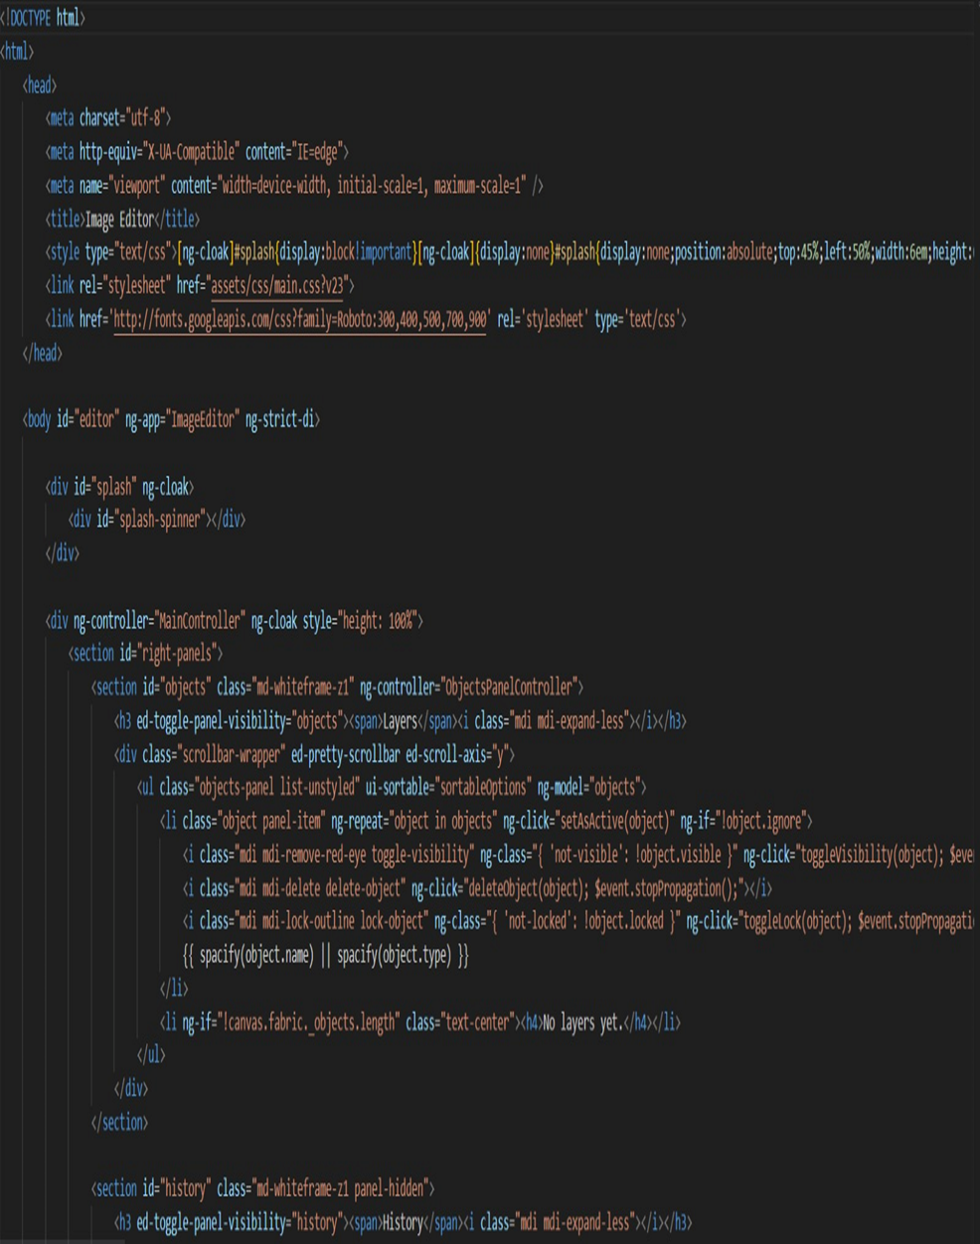

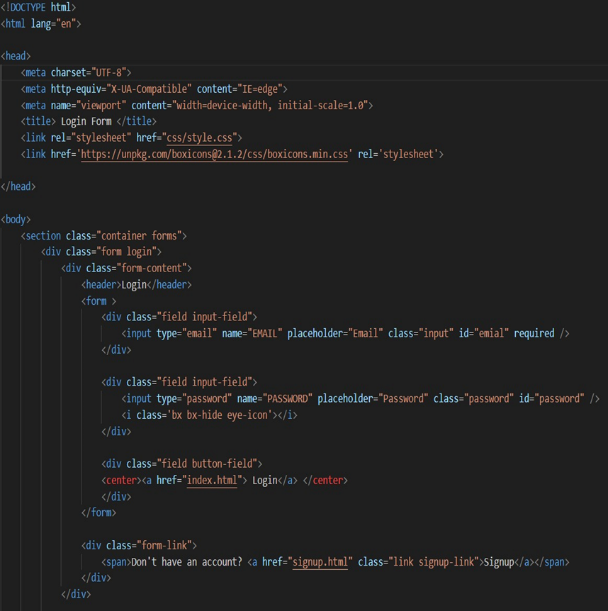

**5.2 Feature 2 - Adaptive Object Detection and Occupancy Analysis**

**Description:** This feature enables the system to adapt to different photo layouts and photo sizes, ensuring accurate object detection and occupancy analysis.

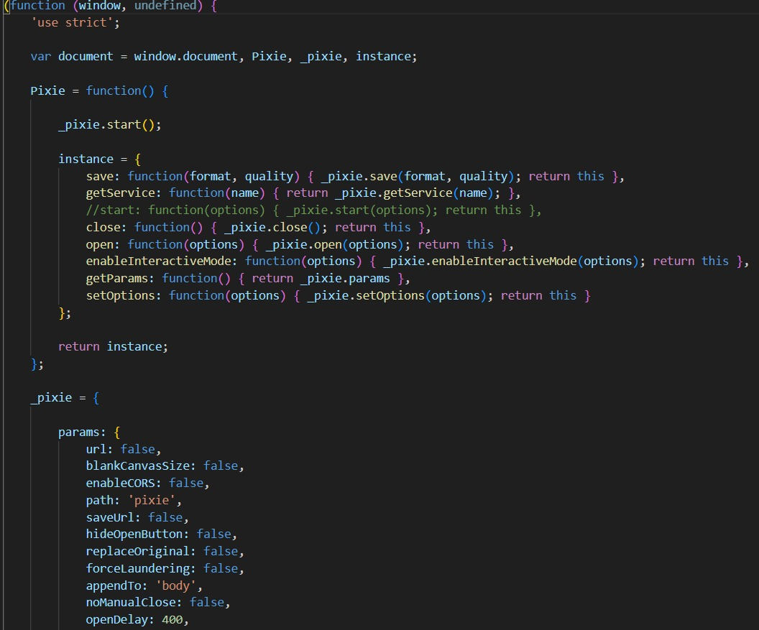

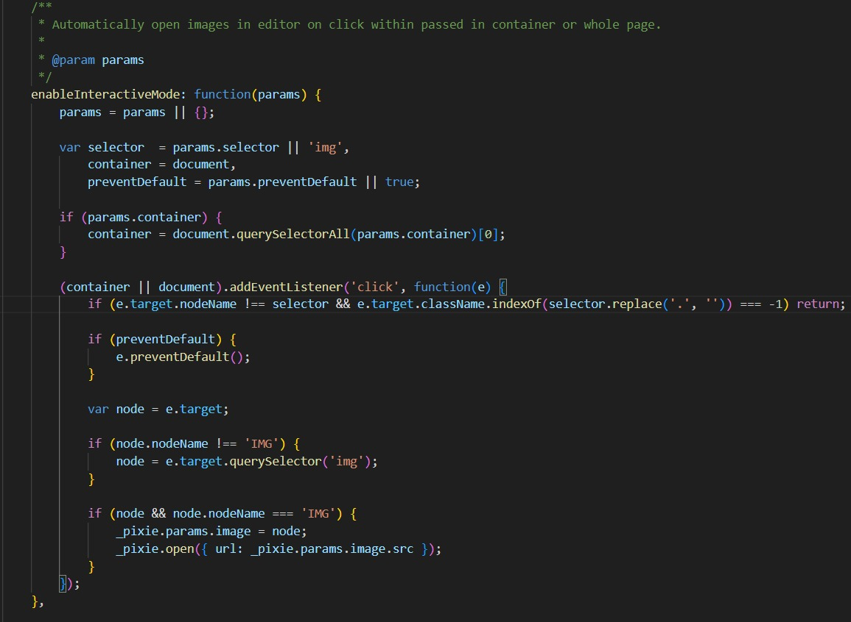

**5.3 Database Schema – Login & Sign Up**

If the project involves storing and managing data related to login and sign up, a database schema can be implemented. The schema will define the structure and relationships of the database tables. Here is a simplified example of a database schema:

**Table:**

**User Table:**

**Fields:** user_id, username, email, password, created_at, updated_at

Purpose: Stores user information, including unique identifiers, login credentials, and timestamps for account creation and updates.

**Photo Table:**

**Fields:** photo_id, user_id, file_name, file_path, upload_date, description, likes, views

Purpose: Stores details about each photo uploaded by users, including the associated user, file information, upload date, description, and metrics like likes and views.

**Editing History Table:**

**Fields**: history_id, user_id, photo_id, edit_date, edit_description

Purpose: Keeps track of the editing history for each photo, including the associated user and photo, edit date, and a description of the editing changes made.

**Album Table:**

**Fields:** album_id, user_id, album_name, created_at

Purpose: Stores information about albums created by users, including the associated user, album name, and timestamp for album creation.

**Comment Table:**

**Fields:** comment_id, user_id, photo_id, comment_text, comment_date

**Purpose:** Stores comments made by users on specific photos, including the associated user and photo, comment text, and timestamp.

**Like Table:**

**Fields:** like_id, user_id, photo_id, like_date

**Purpose:** Tracks the likes given by users to photos, including the associated user, photo, and timestamp.

The database schema consists of two main tables: PhotoSpaces, and Camera.

The Photo Spaces table stores information about individual parking spaces, including a unique identifier (id), space number, occupancy status, location, and timestamp of the latest update.

The Camera table stores information about the cameras installed in the parking lot, including a unique identifier (id), name, location, and a foreign key reference to the corresponding parking lot (parking_lot_id).

This database schema allows for the storage and retrieval of parking space information, enabling further analysis and management of the parking lot data.

1. **RESULTS**

**6.1 Performance Metrics:**

When it comes to evaluating the performance of an image editing platform like Pixel Perfection, several metrics can be considered. These metrics help assess the effectiveness, efficiency, and overall quality of the platform. Here are some performance metrics that can be used:

**Speed:** The speed of the image editing platform is crucial. Users expect quick response times when performing edits or applying filters. Speed can be measured by evaluating the time it takes to process various editing tasks, such as applying filters, adjusting colours, or resizing images.

**Accuracy:** Accuracy refers to how well the platform performs the desired edits without introducing artifacts or distortions. It involves evaluating the platform's ability to accurately reproduce colors, retain image details, and handle complex editing tasks such as object removal or background replacement.

**User Experience:** User experience metrics focus on the ease of use and intuitiveness of the platform. This includes evaluating the user interface, the availability of tools and features, the organization of options and settings, and the overall user satisfaction.

**Image Quality:** The quality of the final edited images is a critical metric. It involves assessing the platform's ability to enhance image details, improve colours and contrast, reduce noise, and handle image compression without significant loss of quality. Image quality can be evaluated subjectively through visual inspection and also objectively by measuring image metrics like sharpness, colour accuracy, and noise levels.

**Compatibility:** Compatibility metrics assess the platform's ability to work with various image file formats (such as JPEG, PNG, RAW) and handle different image sizes and resolutions. Compatibility also includes the platform's ability to integrate with external software or services, such as cloud storage or other image editing tools.

**Stability and Reliability:** These metrics evaluate the platform's stability and reliability. It involves measuring the occurrence of crashes, glitches, or unexpected behaviour during image editing sessions. A stable and reliable platform ensures a smooth editing experience for users.

**Scalability:** Scalability refers to the platform's ability to handle a large number of concurrent users or process high-resolution images efficiently. Scalability metrics measure the platform's performance under different workloads to ensure it can handle increased demand without significant degradation in speed or quality.

**Customer Satisfaction:** Customer satisfaction metrics involve gathering feedback from users, such as ratings, reviews, or surveys. This provides insights into user satisfaction with the platform, its features, performance, and overall value.

By evaluating these performance metrics, Pixel Perfection can identify areas for improvement and ensure that the image editing platform meets user expectations in terms of speed, accuracy, user experience, image quality, compatibility, stability, scalability, and customer satisfaction.

**Input video:**



**Output video:**

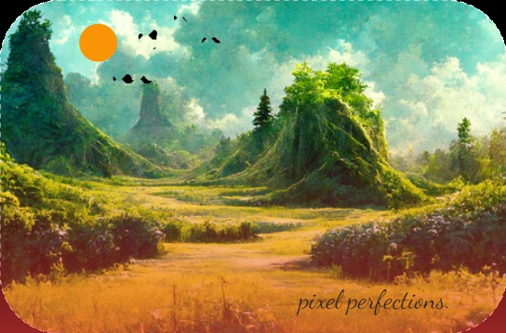

1. **Advantages & Disadvantages**

**Advantages:**

**1.Advanced Editing Features:** Pixel Perfection provides a wide range of advanced editing features that enable users to transform their photos with precision and creativity. These features may include powerful tools for adjusting exposure, colour balance, contrast, and sharpness. The platform may also offer advanced retouching options, such as blemish removal, object cloning, and content-aware fill, allowing users to enhance their photos to perfection.

**2.Intuitive User Interface:** The platform boasts an intuitive user interface that makes it easy for both beginners and experienced users to navigate and utilize its features effectively. The interface may be designed with a user-friendly layout, clear labelling of tools and options, and customizable workflows, ensuring a smooth and efficient editing experience.

**3.Cutting-Edge Technology:** Pixel Perfection utilizes cutting-edge image processing algorithms and technologies to deliver high-quality editing results. This may include advanced image enhancement algorithms, noise reduction techniques, AI-powered tools for automatic adjustments, and machine learning capabilities that help users achieve professional-level editing outcomes.

**4.Speed and Performance:** The platform focuses on providing fast and efficient editing capabilities, allowing users to work seamlessly without significant delays. It may leverage optimized algorithms, parallel processing, and hardware acceleration to ensure quick processing and real-time preview of edits, enhancing productivity and workflow efficiency.

**5.Cloud-Based and Cross-Platform Compatibility:** Pixel Perfection may offer a cloud-based solution, allowing users to access their editing projects from anywhere, collaborate with others, and synchronize their work across multiple devices. It may also provide cross-platform compatibility, enabling users to edit their photos on various devices such as desktops, laptops, tablets, and smartphones, ensuring flexibility and convenience.

**6.Integration and Workflow Enhancements:** The platform may integrate with other popular tools and services, such as cloud storage platforms, stock photo libraries, or social media platforms. This integration streamlines the editing workflow, making it easier to import and export photos, share edited images, and leverage additional resources for a comprehensive editing experience.

**7.Learning Resources and Community Support:** Pixel Perfection may provide a range of learning resources, including tutorials, documentation, and user forums, to help users learn and master the platform's features. The presence of an active user community allows for knowledge sharing, troubleshooting, and inspiration, fostering a supportive environment for users to enhance their editing skills.

**8.Regular Updates and Improvements:** To stay at the forefront of image editing technology, Pixel Perfection may regularly release updates and improvements. These updates may include bug fixes, performance optimizations, new features, and enhanced compatibility, ensuring that users benefit from the latest advancements in the field of image editing.

**Disadvantages:**

**1.Learning Curve:** Due to its advanced features and capabilities, Pixel Perfection may have a steeper learning curve for beginners or users who are not familiar with image editing software. The extensive range of tools and options may require some time and effort to fully grasp and utilize effectively.

**2.Cost:** Advanced image editing platforms often come with a price tag. Pixel Perfection may require a subscription or one-time purchase fee, which may be a disadvantage for users who are on a tight budget or unwilling to invest in premium software.

**3.System Requirements:** Cutting-edge image editing platforms like Pixel Perfection may have higher system requirements in terms of hardware and software. Users might need a powerful computer or device with sufficient processing power, memory, and storage to run the platform smoothly. This could limit accessibility for users with older or less capable devices.

**4.Reliance on Internet Connectivity:** If Pixel Perfection is a cloud-based image editing platform, it may require a stable internet connection for seamless access and functionality. This can be a drawback for users in areas with unreliable or limited internet connectivity, hindering their ability to utilize the platform effectively.

**5.Limited Offline Functionality:** Cloud-based platforms like Pixel Perfection may have limited functionality or reduced features when offline. This can be inconvenient for users who need to edit photos while traveling or in situations where an internet connection is not available.

**6.Dependency on Subscription Model:** If Pixel Perfection operates on a subscription-based model, users may be required to maintain an active subscription to access the platform and its features. This can be a disadvantage for users who prefer a one-time purchase or who don't want to commit to ongoing payments.

**7.Limited Customization:** Despite offering a range of advanced editing features, Pixel Perfection may have limitations in terms of customization options. Users who require highly specialized or niche editing capabilities may find the platform lacking in specifictools orfunctionalities.

**8.Platform-specific Limitations:** Depending on the specific implementation of Pixel Perfection, there may be limitations or incompatibilities with certain operating systems, devices, or file formats. Users may need to ensure their specific requirements align with the platform's capabilities to avoid any compatibility issues.

**Appendix:**

An appendix could be a section or document that provides additional information, supplementary materials, or reference materials related to the platform. Here are some examples of what could be included in an appendix for Pixel Perfection:

**1.Keyboard Shortcuts:** A list of keyboard shortcuts commonly used in Pixel Perfection. This appendix can serve as a quick reference guide for users to perform various actions or access specific tools more efficiently.

**2.Glossary of Terms:** An appendix that defines and explains commonly used terms, acronyms, or jargon related to image editing and specific features of Pixel Perfection. This helps users better understand the terminology used within the platform and enhances their overall knowledge**.**

**3.Troubleshooting Guide:** A troubleshooting appendix that provides solutions to common issues or errors that users may encounter while using Pixel Perfection. This can include step-by-step instructions or workarounds for resolving technical problems, ensuring a smoother user experience.

**4.Sample Workflows:** A collection of sample workflows or editing processes showcasing how to achieve specific editing goals using Pixel Perfection. This appendix can provide users with practical examples and guidance for different types of editing tasks, such as portrait retouching, landscape enhancement, or creative effects.

**5.Tips and Tricks:** An appendix featuring tips, tricks, and advanced techniques for using Pixel Perfection effectively. This can include shortcuts, hidden features, or lesser-known functionalities that can help users optimize their editing workflow or achieve specific effects.

**6.External Resources:** A compilation of external resources, such as tutorials, articles, or video demonstrations, that provide additional guidance or inspiration for using Pixel Perfection. This appendix can include references to online communities, blogs, or educational platforms where users can expand their knowledge and skills**.**

**7.FAQ:** An appendix containing frequently asked questions (FAQ) and their corresponding answers related to Pixel Perfection. This appendix addresses common queries or concerns that users may have and provides concise answers or solutions.

1. **Conclusion:**

Pixel Perfection is a cutting-edge image editing platform that offers advanced features, intuitive user interface, and powerful editing capabilities. With its range of tools and technologies, it enables users to transform their photos with precision, creativity, and efficiency.

The platform stands out for its advanced editing features, including options for adjusting exposure, colour balance, contrast, and sharpness. It also offers advanced retouching tools, such as blemish removal and object cloning, allowing users to enhance their photos to perfection. Additionally, Pixel Perfection leverages cutting-edge image processing algorithms, noise reduction techniques, and AI-powered tools to deliver high-quality editing results.

The user interface of Pixel Perfection is designed to be intuitive, making it accessible to both beginners and experienced users. Its layout, labelling of tools, and customizable workflows ensure a smooth and efficient editing experience. The platform may also offer cloud-based functionality and cross-platform compatibility, allowing users to access and edit their photos from anywhere and on various devices.

While there may be potential disadvantages, such as a learning curve, system requirements, and cost, these factors need to be weighed against the platform's advantages. Regular updates, integration with other tools and services, learning resources, and customer support contribute to a comprehensive user experience.

Overall, Pixel Perfection aims to provide users with a powerful and comprehensive image editing platform, empowering them to transform their photos with precision and creativity. With its cutting-edge technology, advanced features, and intuitive interface, Pixel Perfection strives to be a valuable tool for both amateur and professional photographers, graphic designers, and anyone seeking to enhance their images.

1. **Future Scope:**

There are several areas of potential development and improvement for Pixel Perfection to further enhance the image editing experience. Here are some ideas for future work in Pixel Perfection:

1.AI-Powered Editing Enhancements: Leveraging advancements in artificial intelligence and machine learning, Pixel Perfection can continue to improve its AI-powered editing tools. This includes features like automatic subject recognition, intelligent content-aware fill, advanced noise reduction algorithms, and smart suggestions for enhancing images based on user preferences.

2.Expanded Filter Library: Pixel Perfection can expand its library of filters to offer users a wider range of creative options. This may include artistic filters, vintage effects, film simulations, and customizable filter resets to cater to different editing styles and preferences.

3.Seamless Integration with External Tools: Enhancing the platform's integration capabilities with external tools and services can provide users with a more streamlined editing workflow. This can include direct integration with popular cloud storage platforms, seamless collaboration features, and compatibility with external plugins or extensions.

4.Enhanced Mobile Editing Experience: As mobile photography continues to grow in popularity, optimizing Pixel Perfection for mobile devices can be a valuable direction for future work. This involves developing a dedicated mobile app that offers a user-friendly interface, efficient editing tools, and seamless synchronization with the desktop version.

5.Augmented Reality (AR) Editing Features: Exploring AR technology for image editing can offer users new and immersive ways to enhance their photos. By integrating AR capabilities, Pixel Perfection can provide features like virtual object placement, augmented reality filters, and real-time preview of edits in a physical environment.

6.Advanced Retouching Tools: Pixel Perfection can further improve its retouching tools to offer more precise and natural-looking edits. This can include advanced skin retouching options, better control over facial features, and specialized tools for handling complex areas like hair or detailed textures.

7.Workflow Automation and Batch Processing: Streamlining the editing workflow through automation and batch processing features can significantly enhance productivity. Pixel Perfection can implement features that allow users to apply a series of edits to multiple images simultaneously, saving time and effort.

8.Improved Performance and Optimization: Continuous optimization and improvement of performance are crucial for any image editing platform. Pixel Perfection can focus on optimizing processing speed, reducing resource usage, and improving overall stability to provide users with a smooth and efficient editing experience.

9.Community Engagement and User Feedback: Engaging with the user community, gathering feedback, and actively incorporating user suggestions can guide future development efforts. Conducting surveys, hosting user forums, and actively addressing user concerns can help shape the direction of future work and ensure that Pixel Perfection meets the evolving needs of its users.

By exploring these avenues of future work, Pixel Perfection can continue to evolve as a cutting-edge image editing platform, providing users with advanced tools, seamless functionality, and an exceptional editing experience.

**Research Papers:**

References to external resources, research papers, or related projects.

Here are some references to external resources, research papers, and related projects

1.Gonzalez, R. C., & Woods, R. E. (2017). Digital Image Processing (4th ed.). Pearson.

(Link: https://ieeexplore.ieee.org/).

2.Burger, W., & Burge, M. J. (2016). Principles of Digital Image Processing: Core Algorithms (2nd ed.). Springer.

(Link: https://ieeexplore.ieee.org/).

3.Szeliski, R. (2010). Computer Vision: Algorithms and Applications. Springer.

**(**Link**:** https://ieeexplore.ieee.org/)

4. Farid, H. (2013). Image Processing: Principles and Applications. Wiley.

(Link: https://ieeexplore.ieee.org/).

**My Source Code:** <https://github.com/naanmudhalvan-SI/IBM--11812-1682399023/tree/61bf49ac4d838639642dbdd056d7c8004325ad24/Final%20Deliverables>

**Project Video Demo**: <https://www.youtube.com/watch?v=UfU4ubTJsF8>